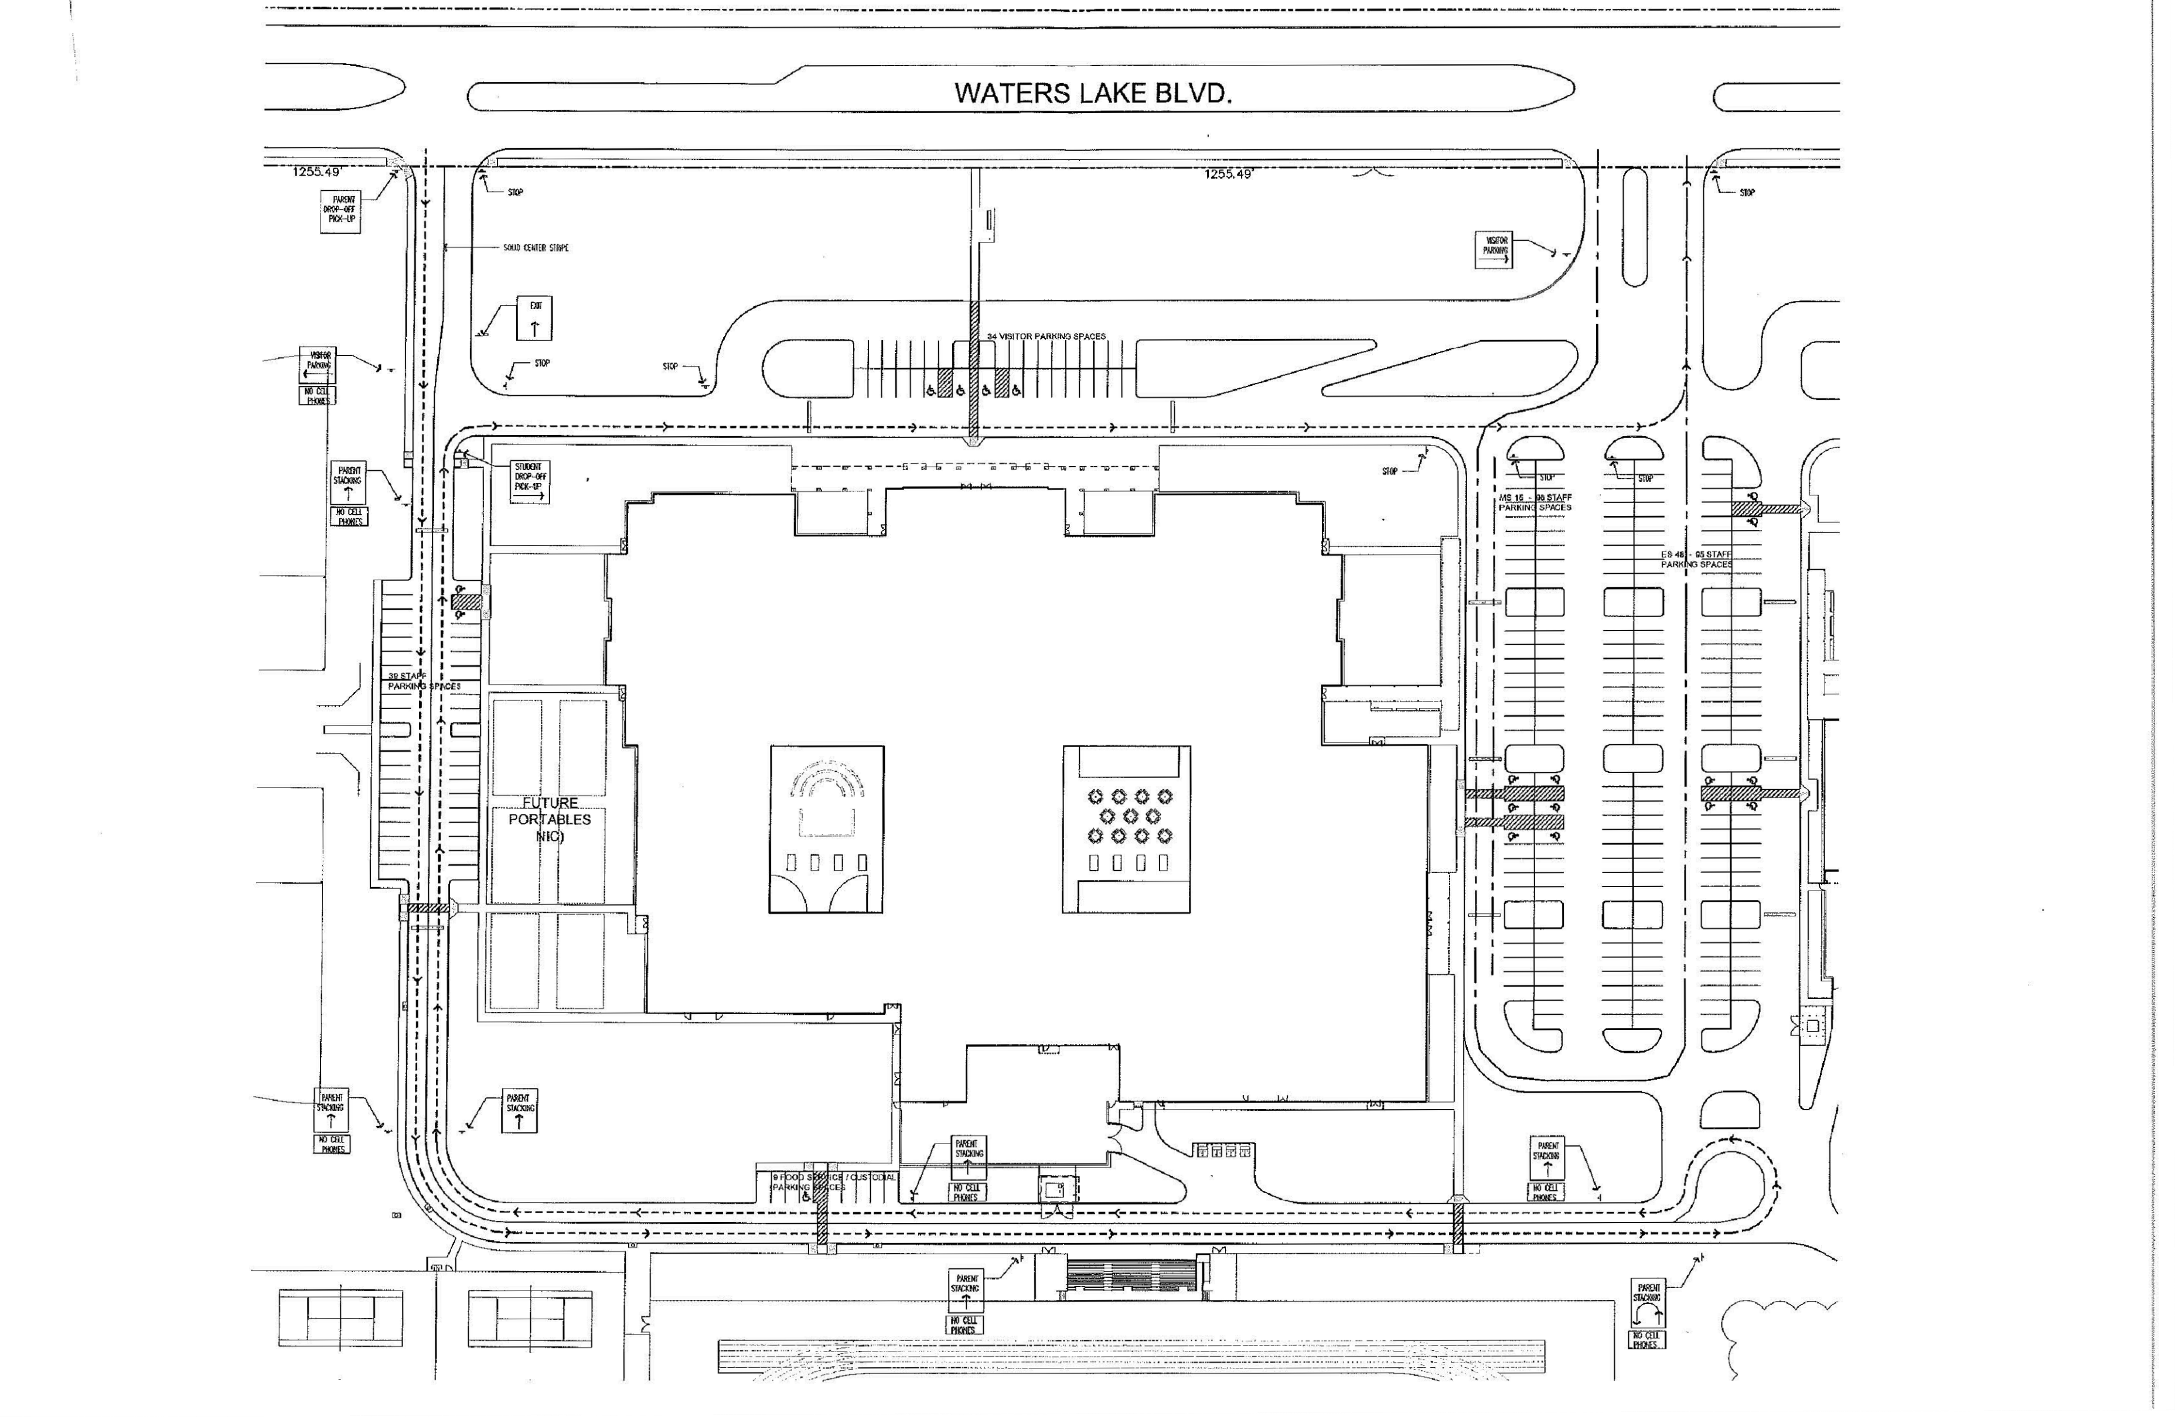

# 

**Ronald Thornton Middle School Front Office**

**Thundercamp Parking**

**GYM**

**Tennis Courts**

**PE & Health**

**Football/Track Field**